**Practical no: 7**

**Aim: Virtualization: Open Source virtualization technologies:**

**Virtual Box .exe install on windows and Click on next when you see the welcome window..**

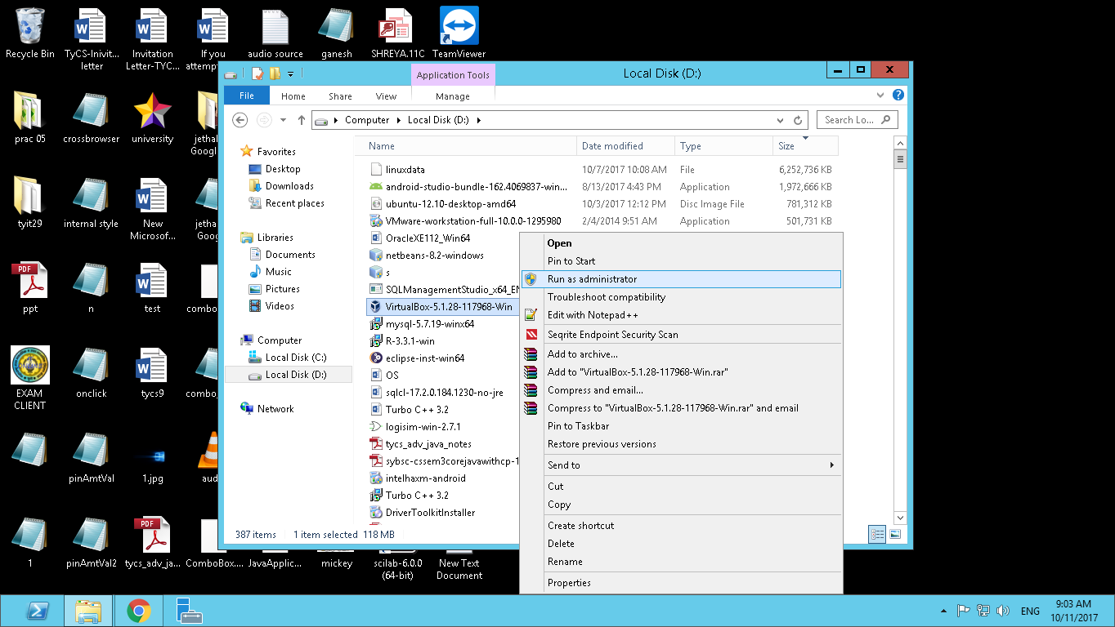 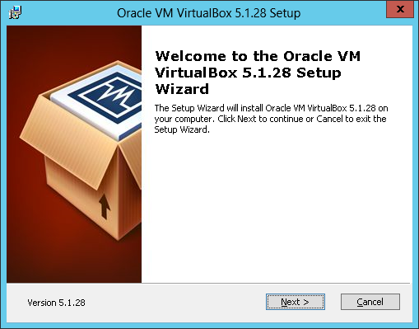

**Click on next when there is all VM VirtualBox selected..**

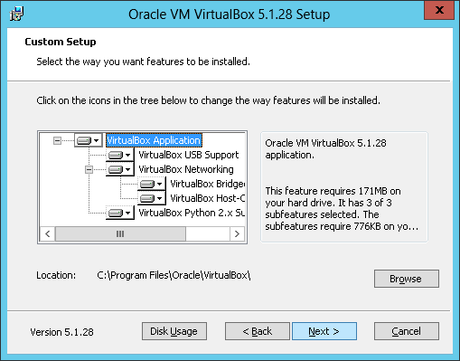 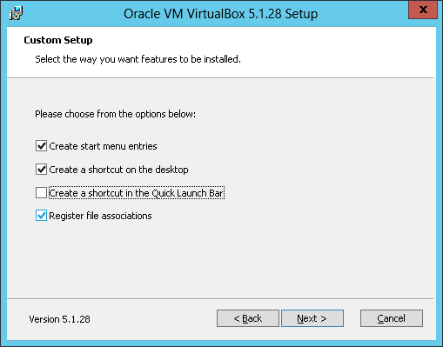

**Then the warning window occurs click on “YES”**

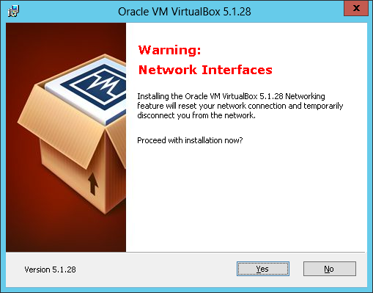

**Then an installation window occurs click on “Install”**

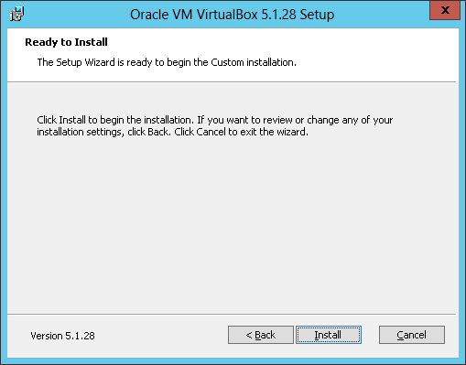

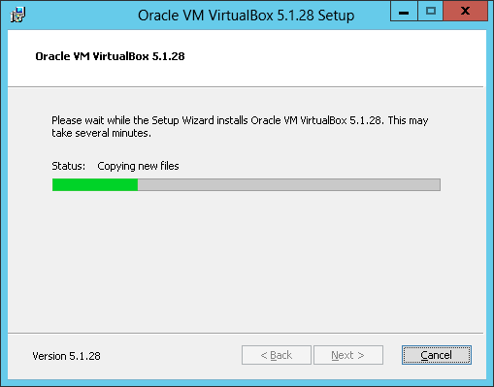

**After the installation gets completed click on “Finish” button**

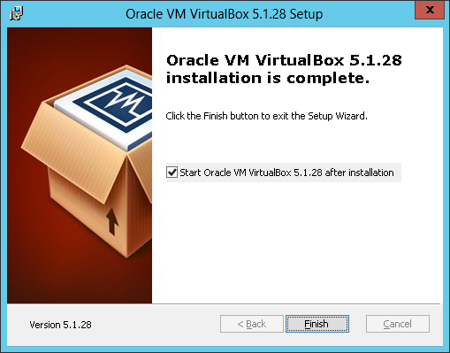

**Now you can see that the window of VirtualBox Appears.**

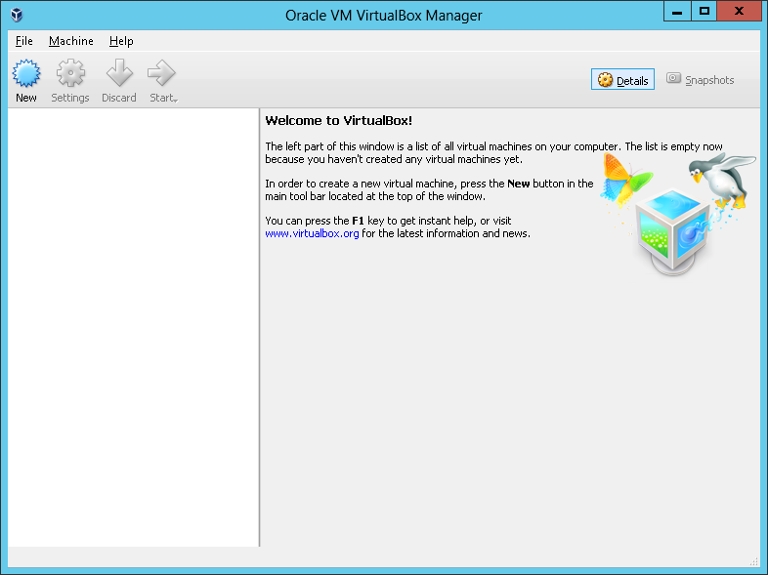

**Now install the operating system in that Virtual Box click on “New” in the left corner**

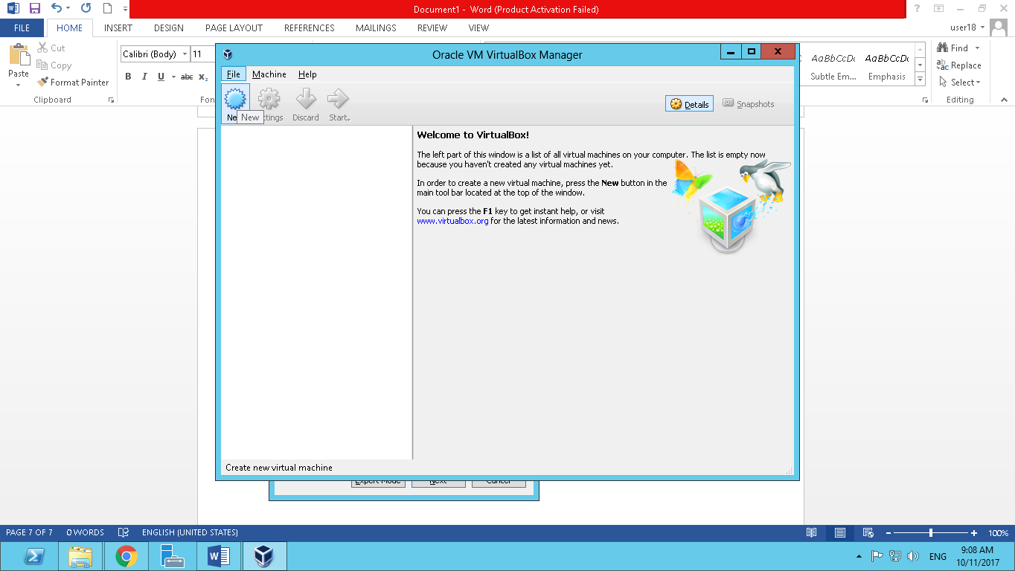

**After clicking New you will be asked which operating system you want to install we will select Linux(for Ubuntu)**

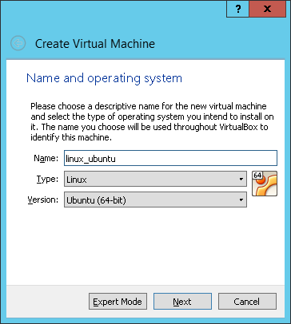

**Let the default size of the Memory**

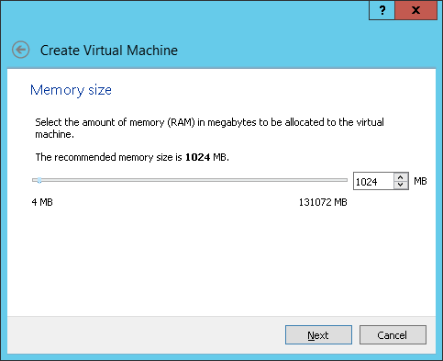

**Select create a virtual hard disk**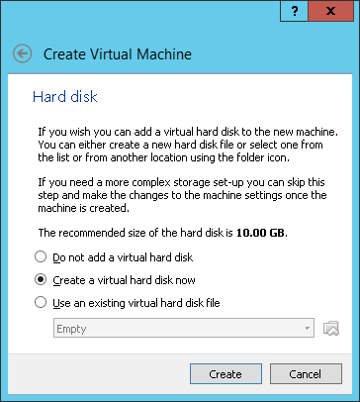

**Create virtual hard disk select the image option and click on next.**

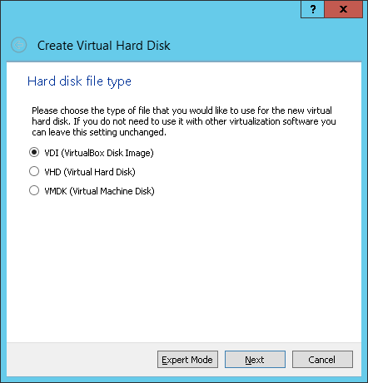

**Select dynamically allocated physical hard disk storage and click on next.**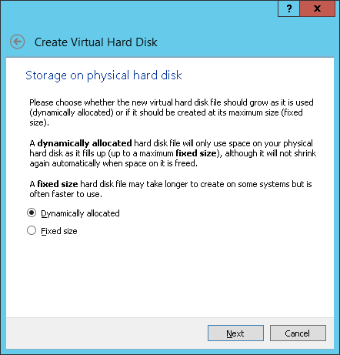

**In the next window click on the create button** 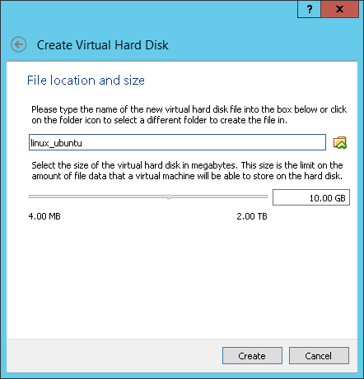

**Here the virtual disk is created now you can insert the iso image i.e. virtual disk image of your operating system**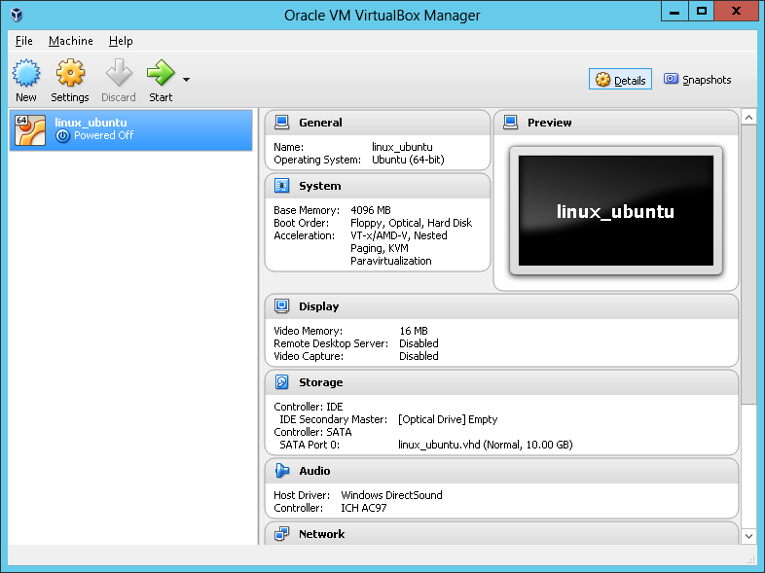

**To insert the iso image perform the following action..**

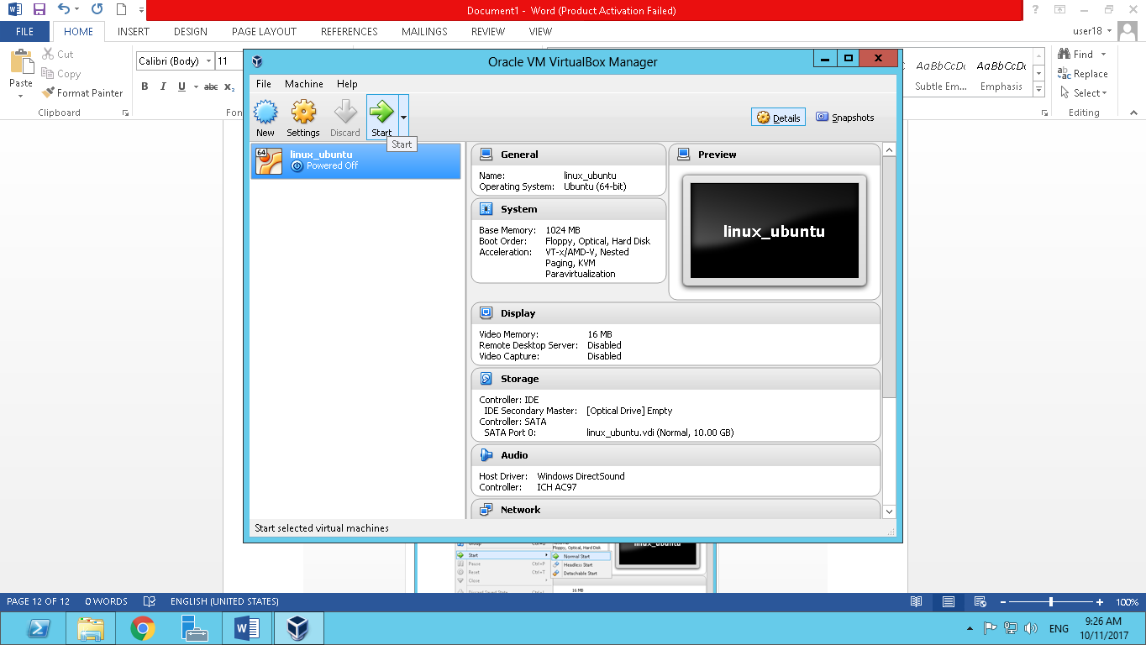

**After starting you go to Devices 🡪 Choose Disk Image 🡪 and a window will appear in that go to the location you saved image and open then your operating system starts running**

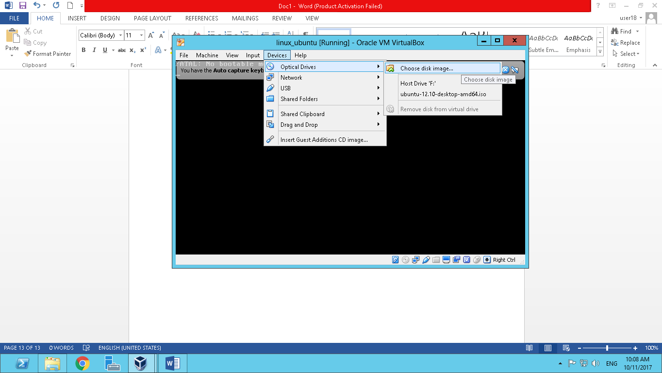

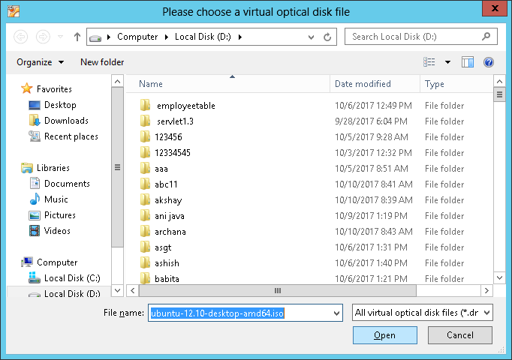

**Your operating systems starts loading and installing.**